

Amazon Web Services

Data Engineering Immersion Day

Lake Formation Lab

March 2020

Table of Contents

Introduction 3

Prerequisites: 3

Tasks Completed in this Lab: 3

Getting Started 4

Setup Network Configuration 4

Create an IAM role to use with Lake Formation: 8

Create Glue JDBC connection for RDS 13

Lake Formation – Add Administrator and start workflows using Blueprints. 15

Explore the Underlying Components of a Blueprint 19

Explore workflow results in Athena 20

[Optional] Grant fine grain access controls to Data Lake user 21

[Optional] Verify data permissions using Athena 22

# Introduction

This lab will give you an understanding of the AWS Lake Formation – a service that makes it easy to set up a secure data lake in days, as well as Athena for querying the data you import into your data lake.

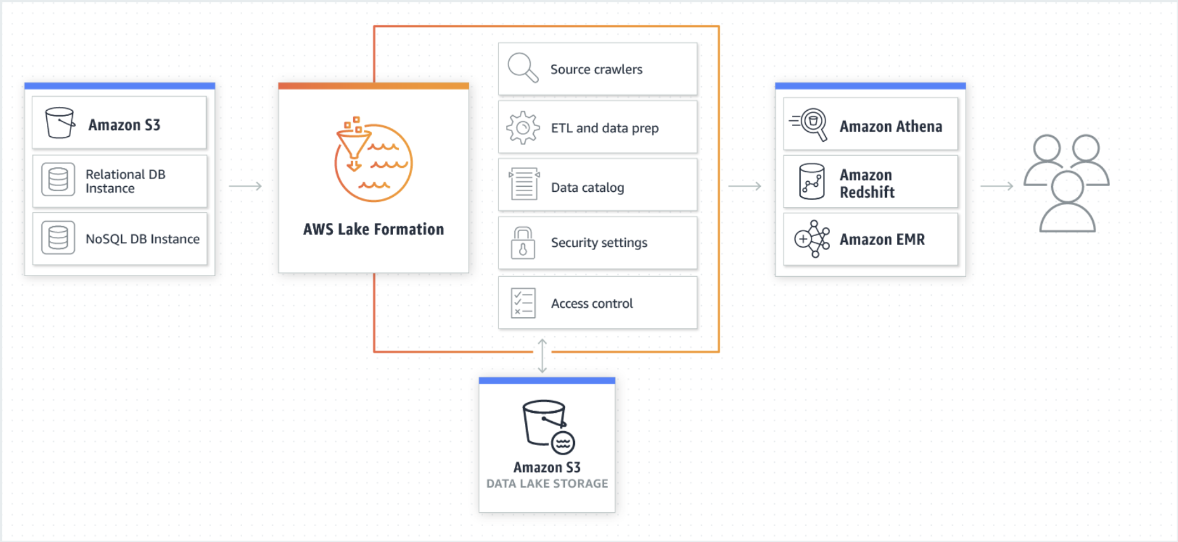

## **Prerequisites:**

The DMS Lab is a prerequisite for this lab.

## **Tasks Completed in this Lab**:

In this lab you will be completing the following tasks:

1. Create a JDBC connection to RDS in AWS Glue
2. Lake Formation IAM Role

NOTE: If your account is already setup with Glue Data catalog permissions then upgrade to Lake Formation Permission set by following -[Link](https://docs.aws.amazon.com/lake-formation/latest/dg/upgrade-glue-lake-formation.html)

1. Lake Formation – Add Administrator and start workflows using Blueprints
2. Explore the components of a Glue WorkFlow created by lake formation
3. Explore workflow results in Athena
4. Grant fine grain access controls to Data Lake user
5. Verify data permissions using Athena

## Getting Started

Navigate to the AWS Glue service.

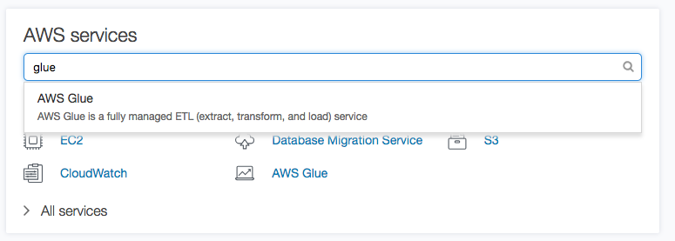

# Setup Network Configuration

To begin with, we need to perform network configuration. We will open ports specific to RDS PostgreSQL DB, define inbound rules and create S3 endpoint to access data in S3 bucket (created as part of DMS Lab)

1. Navigate to **RDS dashboard** and click on the instance. Select “Connectivity and Security” and look for security group. Click on the **security group and** and you will be navigated to VPC Dashboard.

**Note**: Make sure your RDS instance is **available**. If the Status says “Storage Full”, increase the DB storage capacity and apply changes immediately to the DB instance and proceed further.

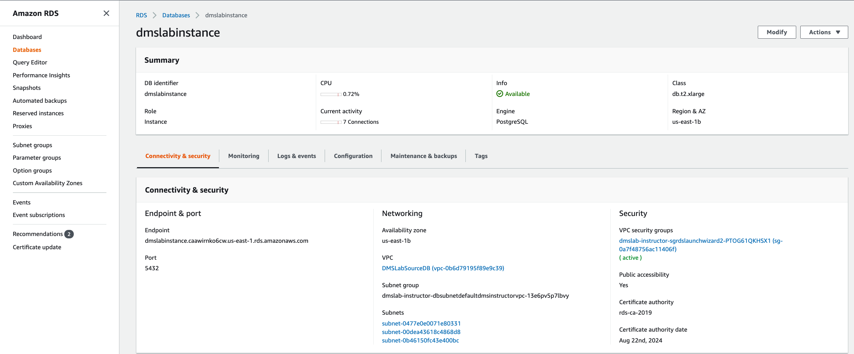

1. Security group associated with RDS instance will be automatically selected. Select Inbound Rules and Click **Edit Rules.**

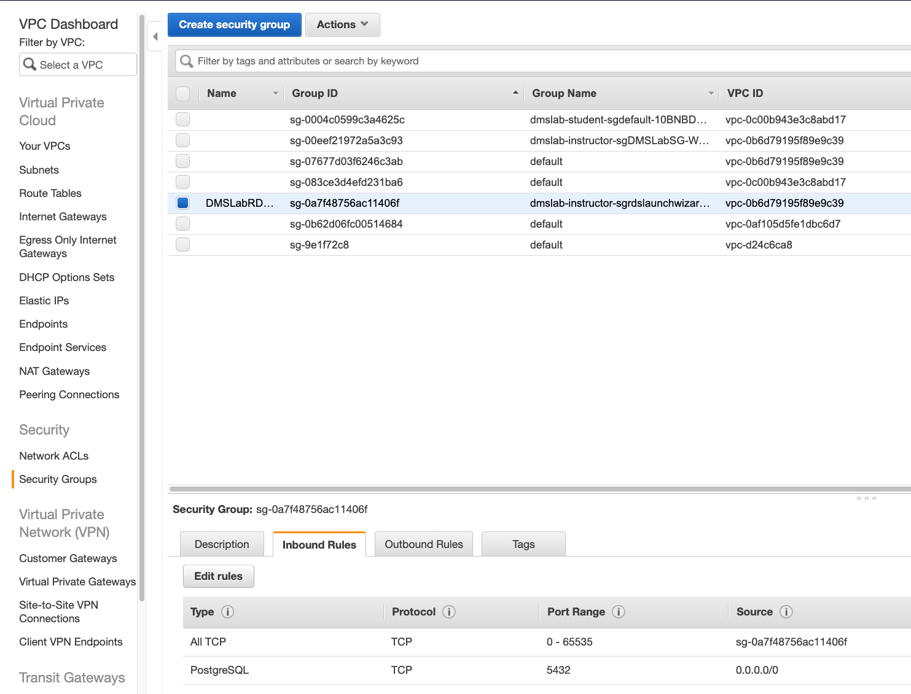

1. Create Inbound Rules as shown below:
   1. All TCP with self-reference of security group as its own source.
   2. PostgreSQL on 5432 from 0.0.0.0/0
   3. Click on **Save Rules**



1. Create S3 VPC endpoint. Navigate to **VPC Dashboard** and select **Endpoint** from left section. Click on “Create Endpoint”.

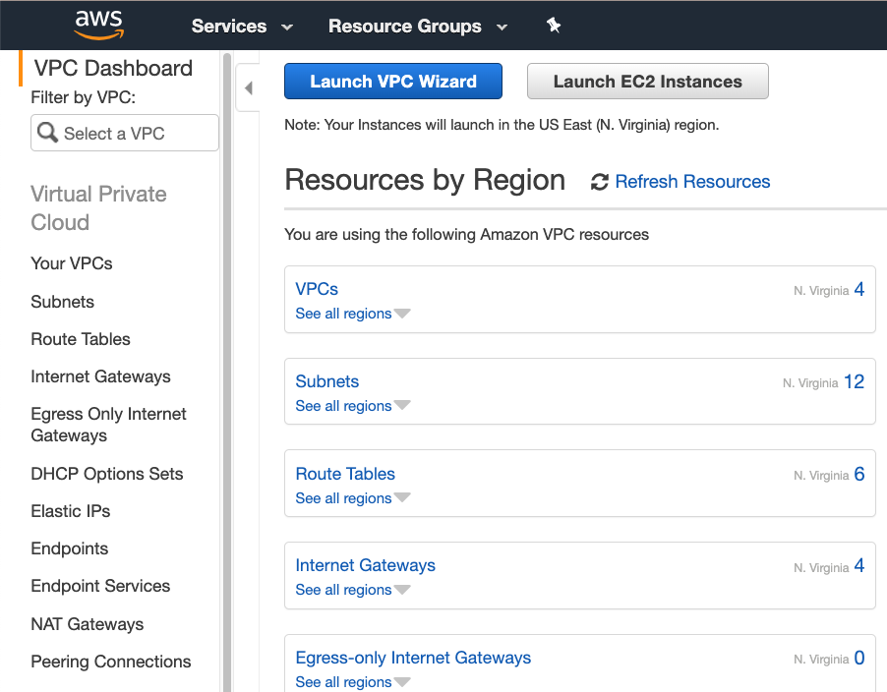

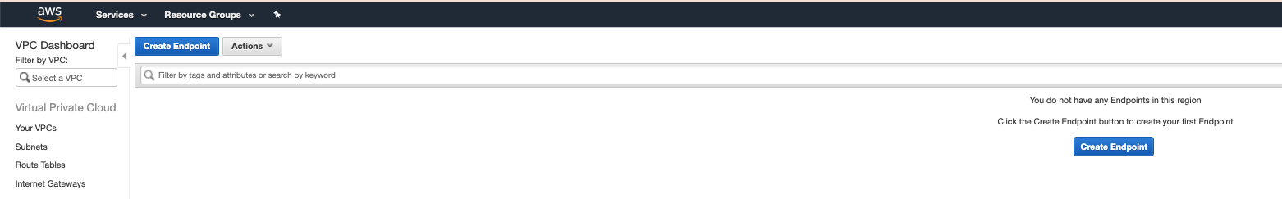

1. In the next window, follow these steps:
   1. Service Category: AWS Services
   2. Service name: com.amazonaws.us-east-1.s3
   3. VPC: same as VPC for RDS instance
   4. Route table: in accordance to subnets
   5. Policy: Full Access
   6. Click on Create Endpoint

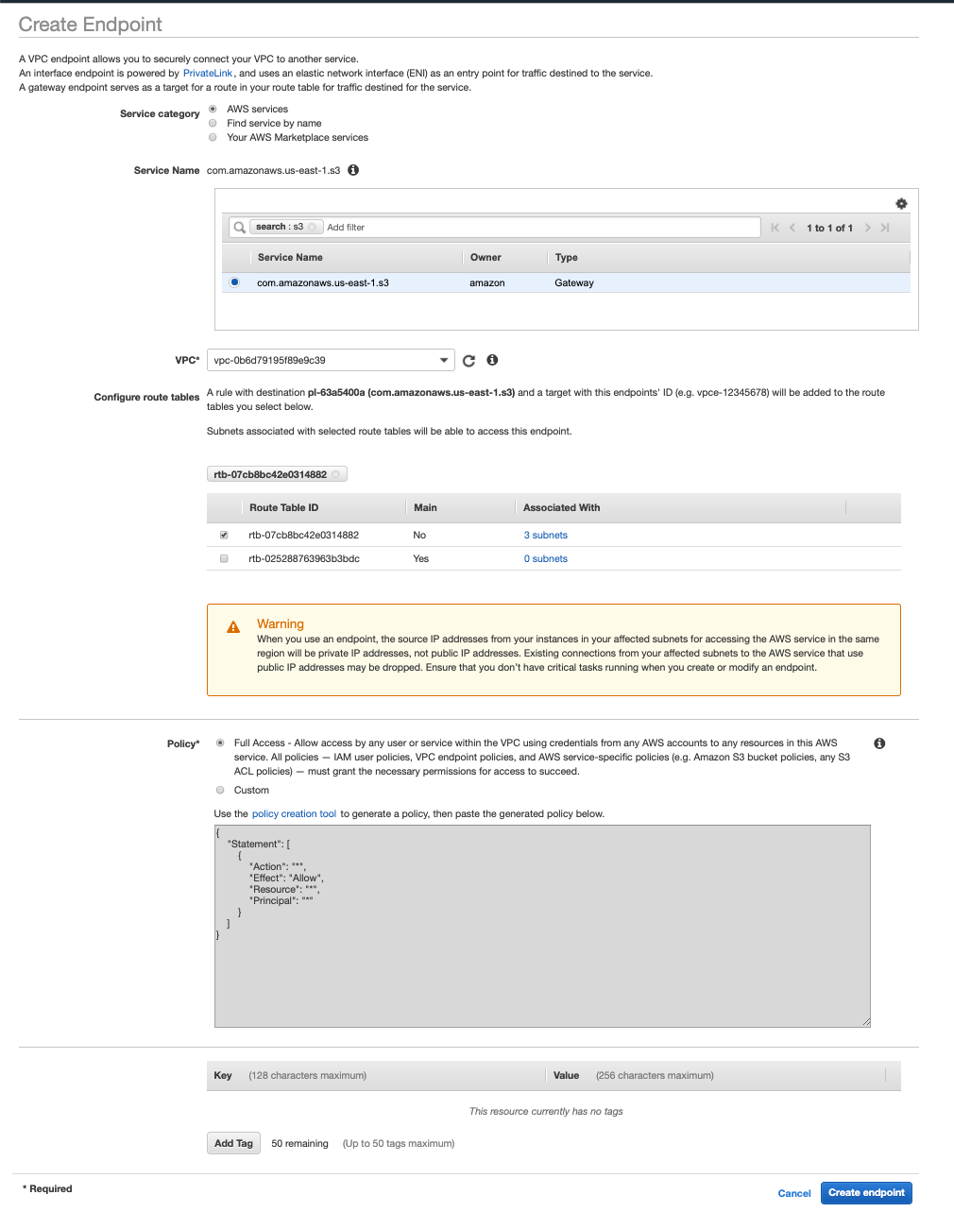

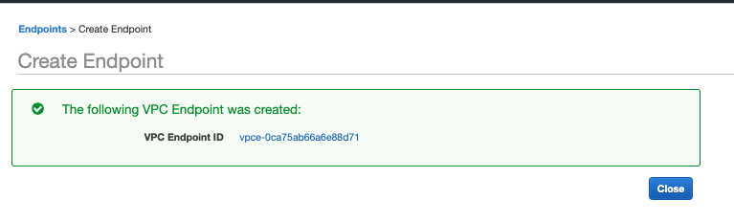

Endpoint creation is successful.

# Create an IAM role to use with Lake Formation:

Documentation Reference: [Link](https://docs.aws.amazon.com/lake-formation/latest/dg/tut-workflow-role.html)

Create the IAM Role by following below steps:

1. On the IAM console, In the navigation pane, choose **Roles**, and then choose **Create role**.

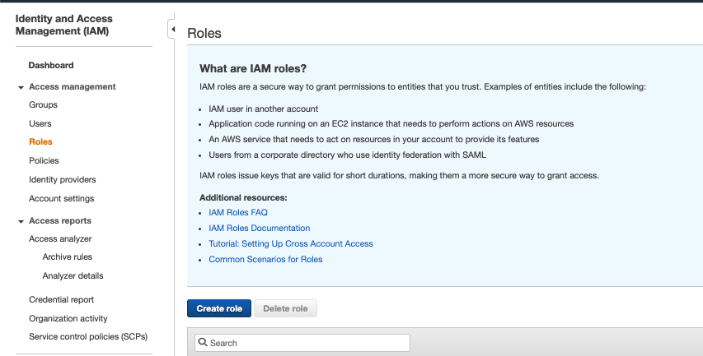

1. On the Create role page, choose **AWS service**, and choose **Glue**. Then choose **Next:Permissions**.

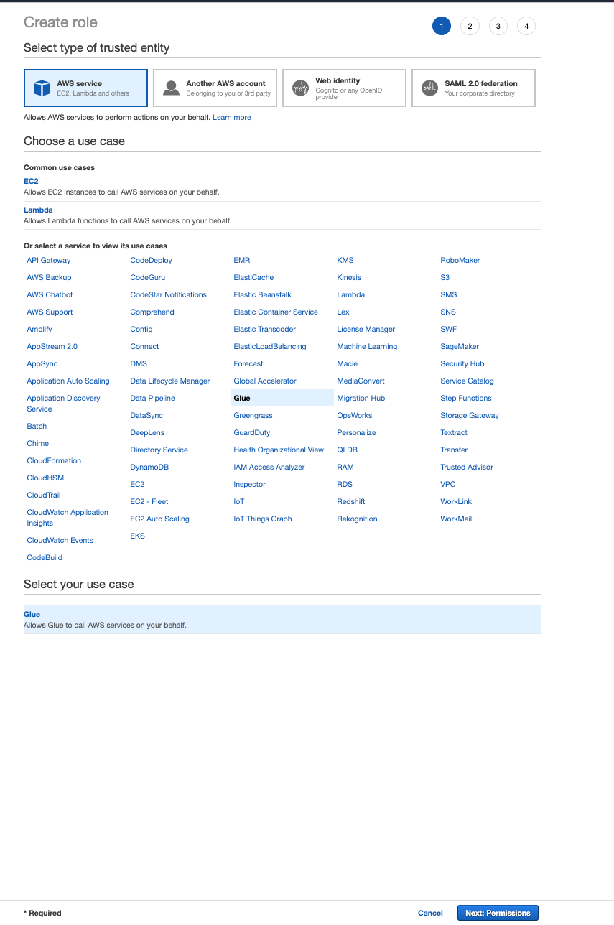

1. Search for and select the **AWSGlueServiceRole** managed policy. Optionally, provide tags.

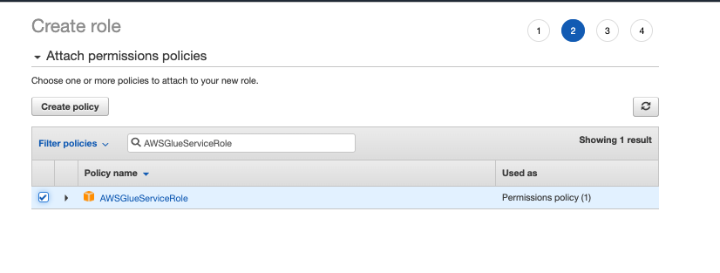

1. Then complete the wizard, naming the role **LakeFormationWorkflowRole**, and choose **Create role**.

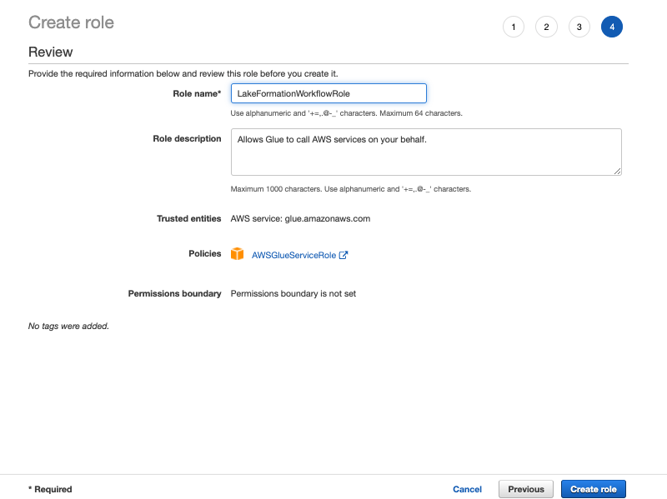

1. Back on the **Roles page**, search for and choose **LakeFormationWorkflowRole**.
2. On the role **Summary page**, under the **Permissions** tab, choose **Add inline policy**, and add the following policy in JSON editor.

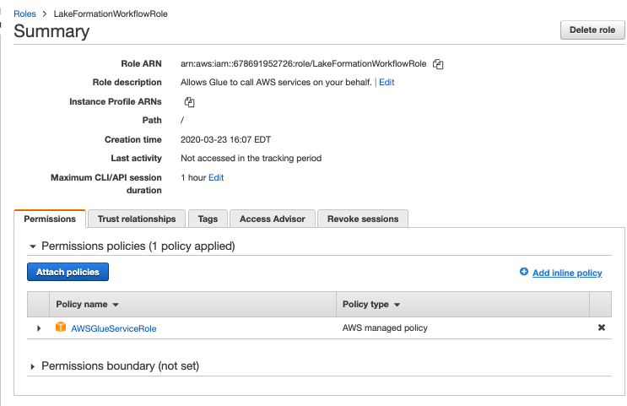

{

"Version": "2012-10-17",

"Statement": [

{

"Sid": "Lakeformation",

"Effect": "Allow",

"Action": [

"lakeformation:GetDataAccess",

"lakeformation:GrantPermissions"

],

"Resource": "*"

}

]

}

1. Name the policy **DatalakeDataAccess** and click on **Create Policy**

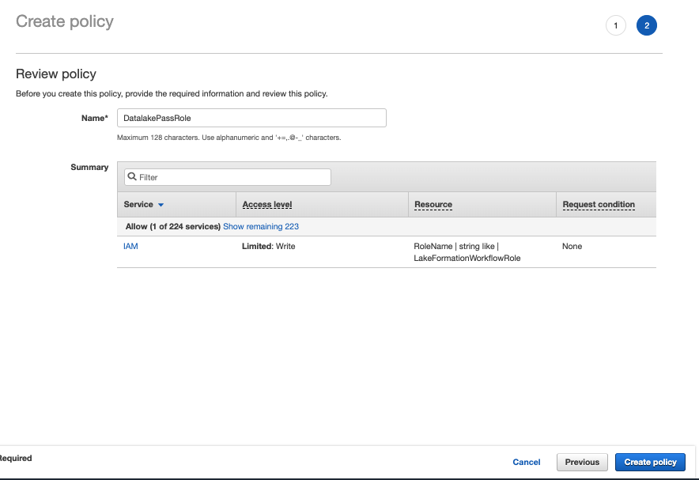

1. **Add another inline policy** that allows the role to pass itself by granting the **PassRole** permission. Name the policy **DatalakePassRole**.

**Important: In the following policy, replace account-id with your AWS account number.** Account ID can be found in Account Summary page.

{

"Version": "2012-10-17",

"Statement": [

{

"Sid": "PassRolePermissions",

"Effect": "Allow",

"Action": ["iam:PassRole"],

"Resource": [

"arn:aws:iam::account-id:role/LakeFormationWorkflowRole"

]

}

]

}

1. Back to policy page, add two more AWS service level permissions: **AmazonS3FullAccess** and **AWSGlueConsoleFullAccess**
2. On the **Summary** page, verify that there are **five policies** attached to the role.

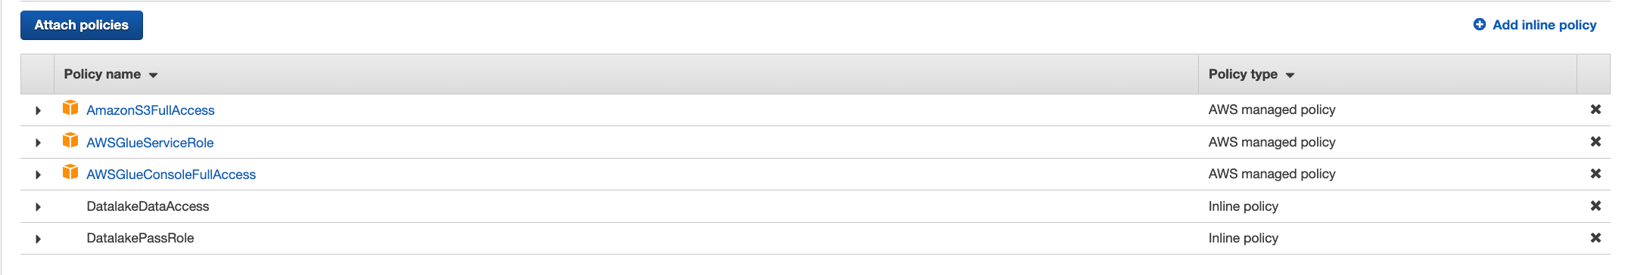

# Create Glue JDBC connection for RDS

1. On the AWS Glue menu, select **Connections**.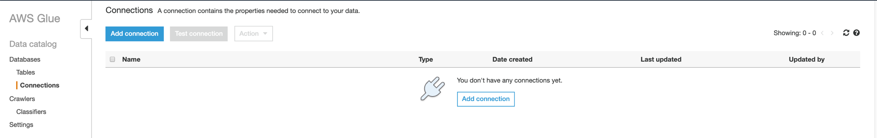
2. Click **Add Connection**.
3. Enter the connection name. This name should be descriptive and easily recognized (e.g ," glue-rds-connection").
4. Choose **RDS** for connection type and **PostgreSQL** for Database Engine
5. Optionally, enter the description. This should also be descriptive and easily recognized and Click **Next**.

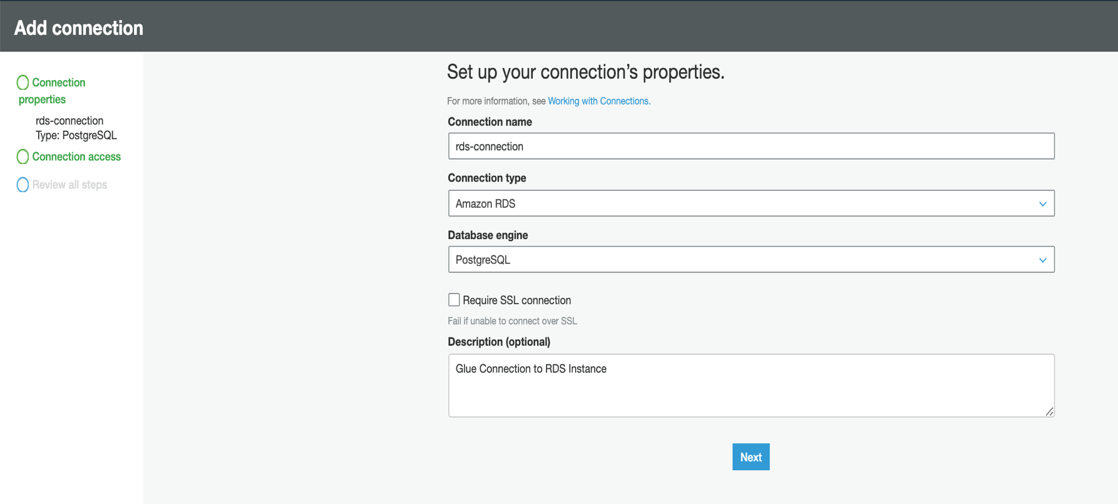

1. Choose **dmslabinstance** as **Instance** and enter password –“master123” **and** Click **Next and** Click **Finish.**

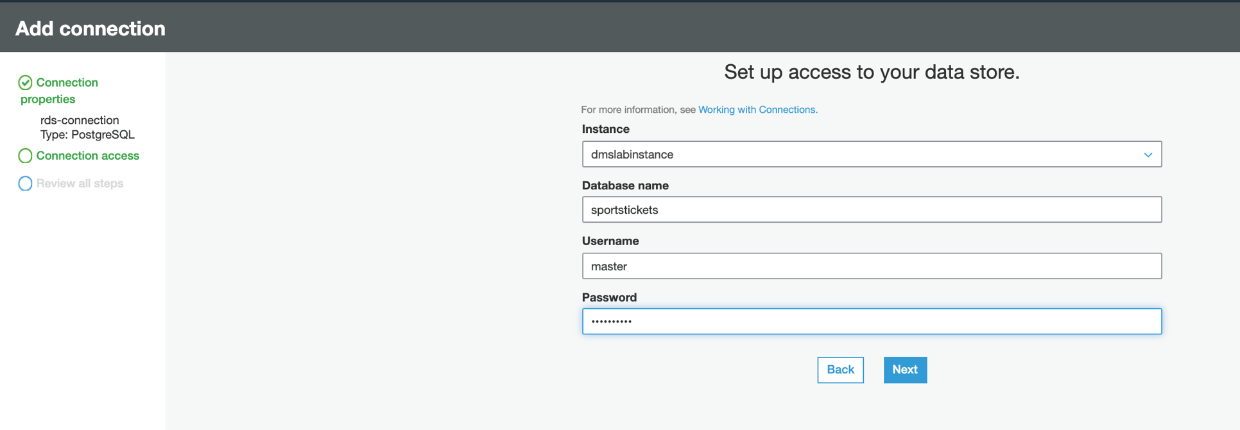

1. **glue-rds-connection** was created successfully. To test it, select the connection, and choose **Test connection**.

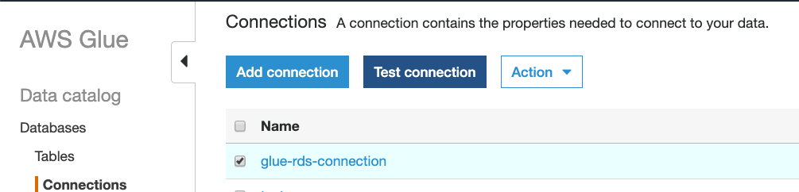

1. To Test connection, choose the IAM role created in the previous step and then click on **Test Connection.**

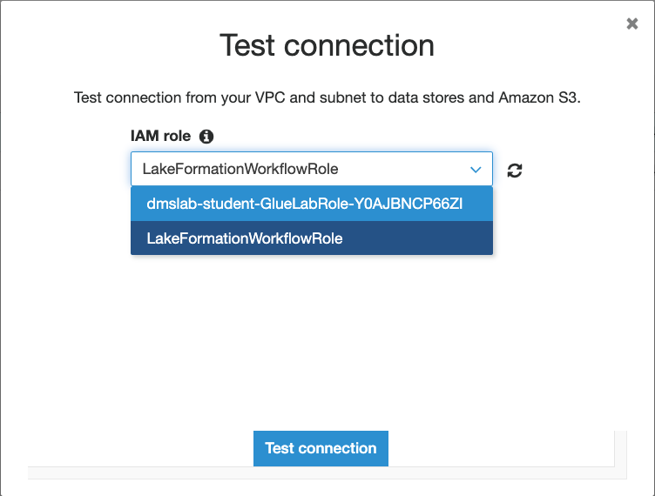

# Lake Formation – Add Administrator and start workflows using Blueprints.

Navigate to the AWS Lake Formation service.

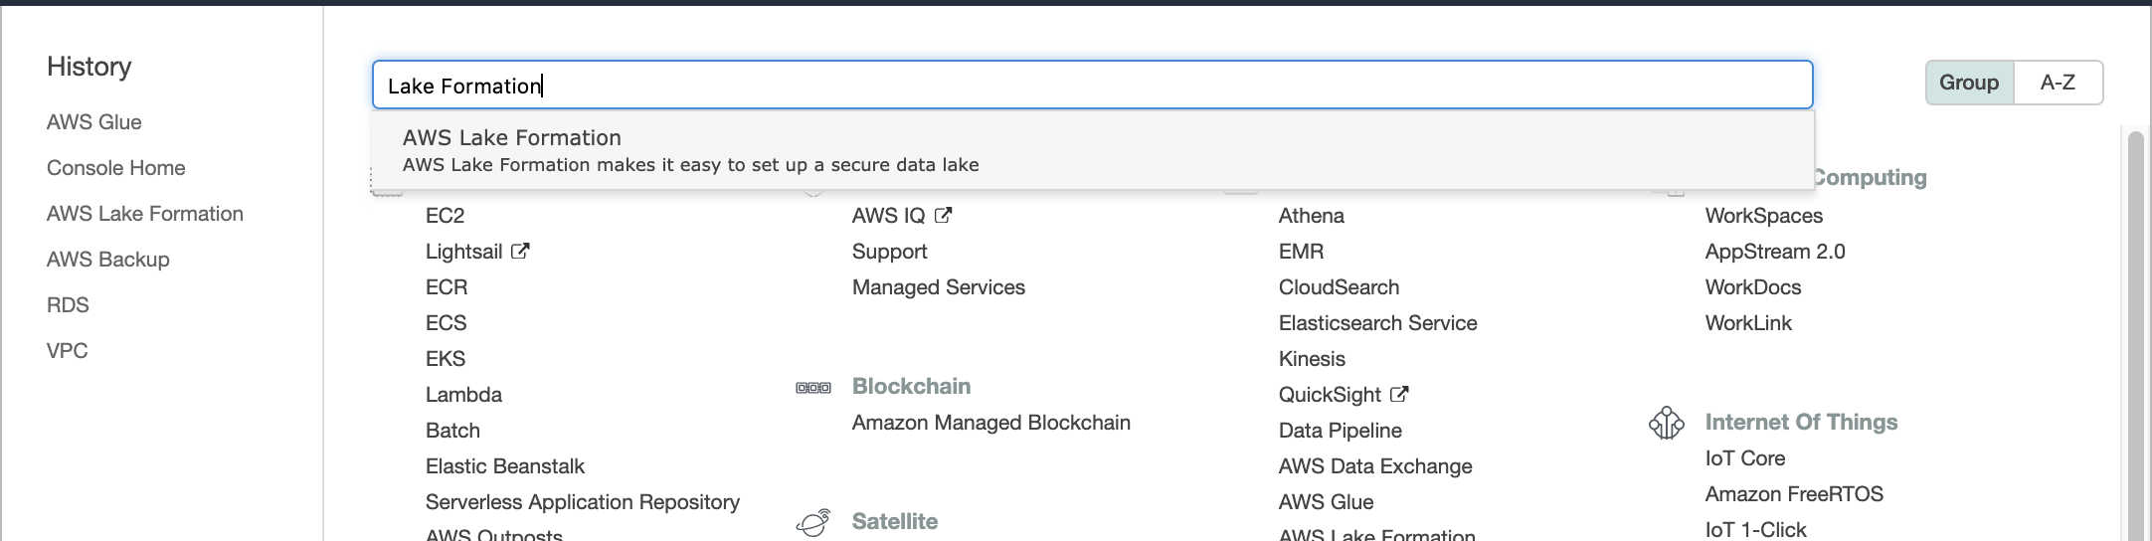

1. If you are logging into the lake formation console for the first time then you must add administrators first in order to do that follow Steps 2 and 3. Else skip to Step 4.
2. Click **Add administrators**

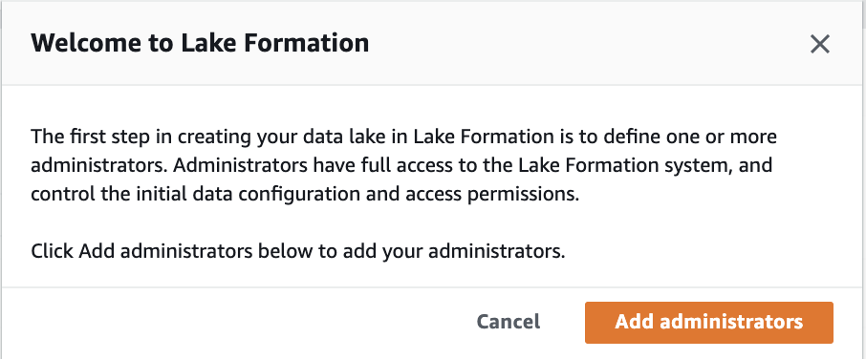

1. Add your <**login user**> as the Lake Formation Administrator and Click **Save**

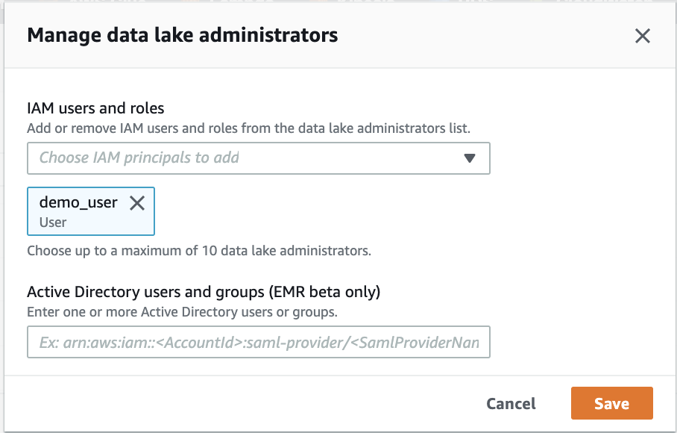

1. Navigate to **Databases** on left pane. Select “**ticketdata**” and click on “**Actions**”, select “**Grant**” to grant permissions.

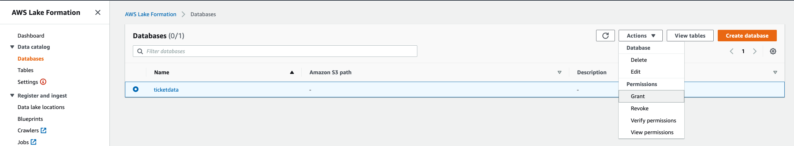

1. Under “**IAM Users and Roles**”, select Lake Formation role that you created – “**LakeFormationWorkflowRole**” and for user, select your **username**. Grant “**super**” permissions for **Database permissions and Grantable permissions.**

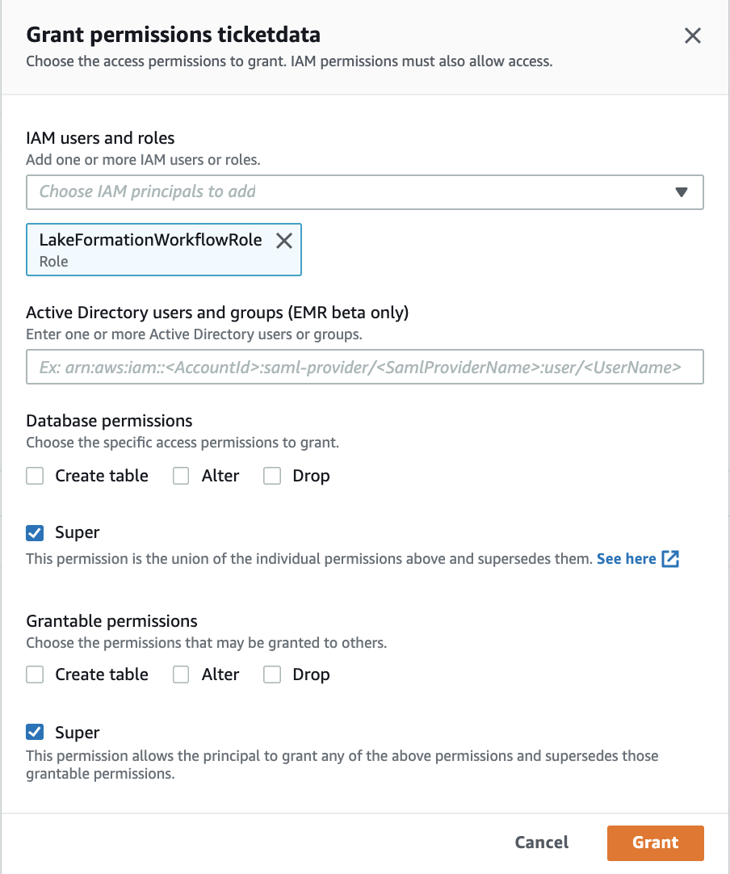

1. On the left pane navigate to **Blueprints** click **Use blueprints**.

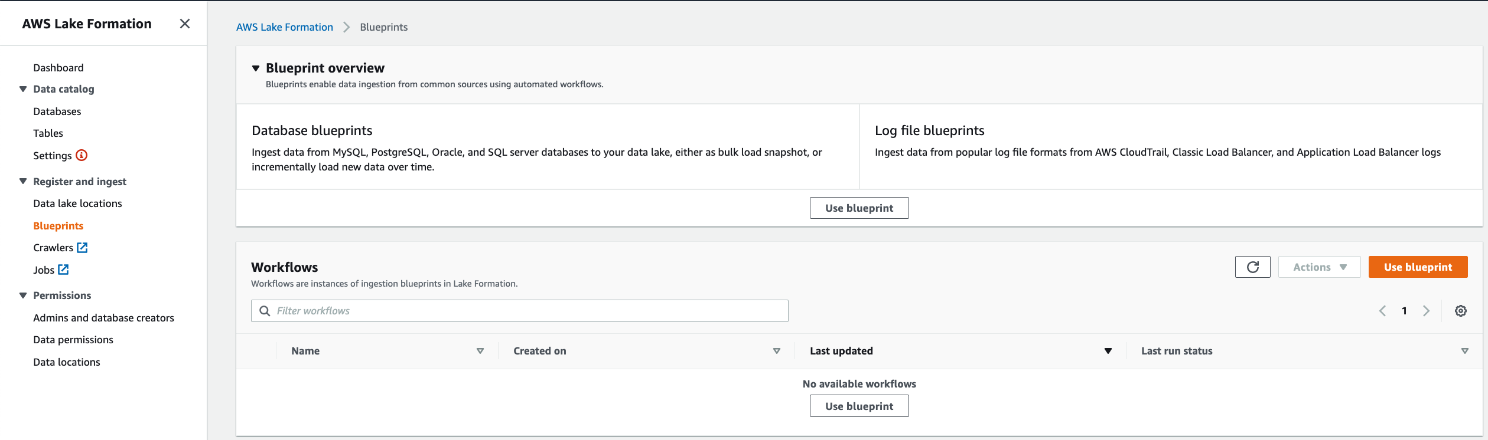

* 1. For **Blueprint Type**, select **Database snapshot**
  2. Under Import Source
     1. For **Database Connection** choose the DB connection created in the glue. [Ex: “glue-rds-connection”]
     2. For **Source Data Path** enter “**sportstickets/dms_sample/player”**.

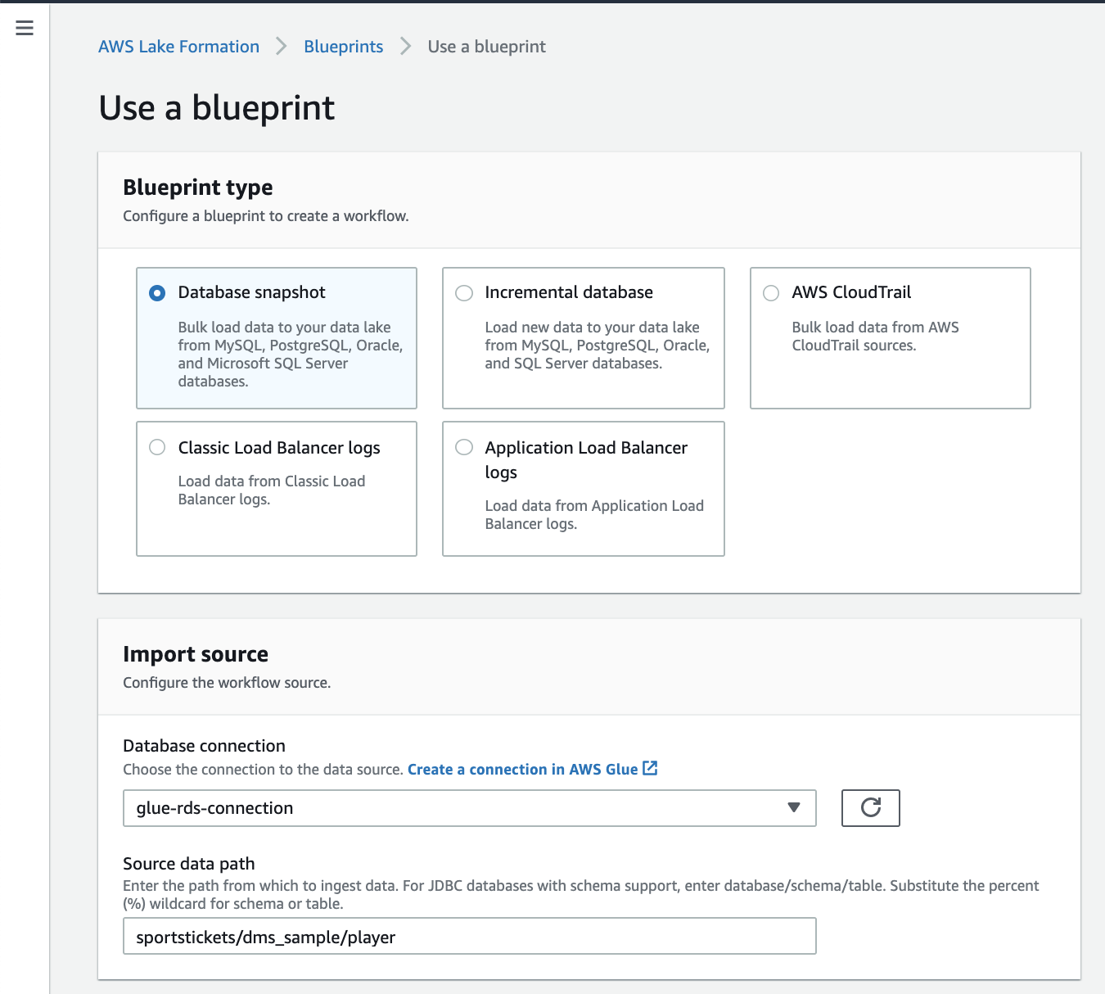

* 1. Under Import Target
     1. For **Target Database**, choose existing “**ticketdata**”.
     2. For **Target storage location** choose the S3 bucket - For Bucket name, type the name of the s3 bucket that you created earlier in student lab.
     3. Add a folder at the end of the bucket url path.

NOTE: The value is similar to the following string, <StackName>-dmslabs3bucket

-<RandomString> for example “dmslab-student-dmslabs3bucket-q29vwhf8n41w/**lakeformation**”

* + 1. For **Data Format** choose **Parquet**

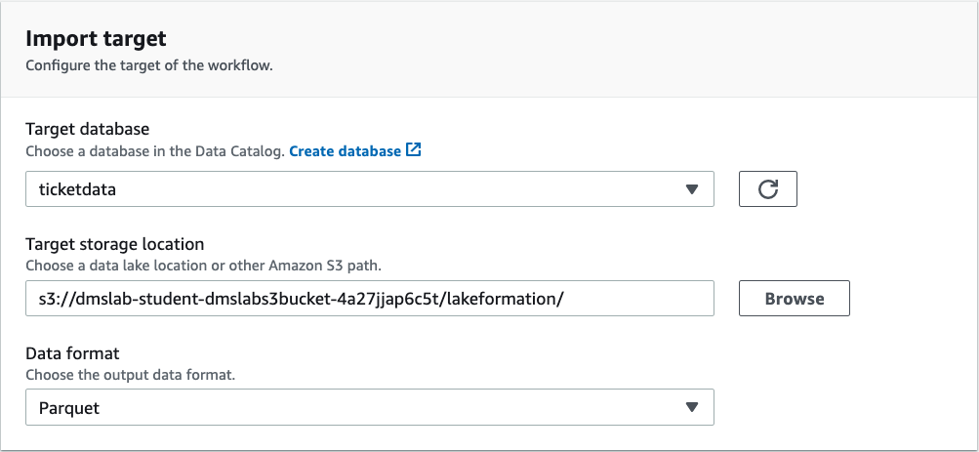

* 1. For **Import Frequency**, Select **Run On Demand**
  2. For **Import Options**;
     1. Give a suitable **Workflow Name**
     2. Forthe **IAM role** choose the **LakeFormationWorkflowRole** created previously
     3. For **Table prefix** type “**lakeformation_”**

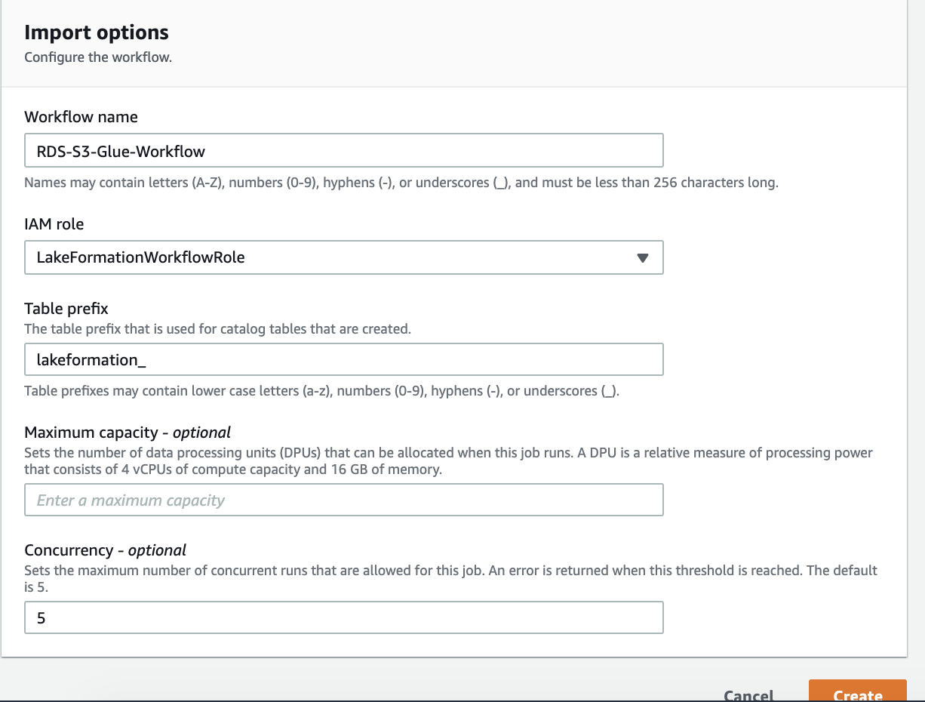

1. Leave other options as default, Choose **Create**, and wait for the console to report that the workflow was successfully created.
2. Once the blueprint gets created, click on **Start it Now?**

[There may be a delay of 5-10s delay in the blueprint showing up. You may have to **hit** **refresh**. Select the blueprint and choose **Start** in **Actions drop down**]

1. Once the workflow starts executing, you will see the status changes from running 🡪 discovering 🡪

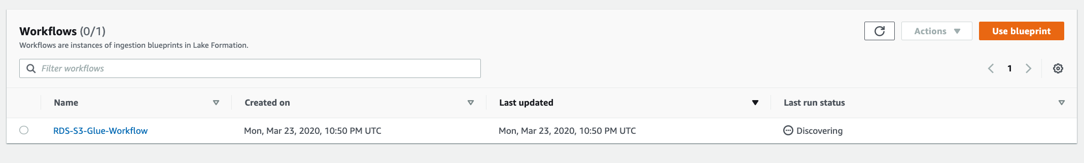

# Explore the Underlying Components of a Blueprint

The Lake Formation blueprint creates a Glue Workflow under the hood which contains Glue ETL jobs – both python shell and pyspark; Glue crawlers and triggers. It will take somewhere between 15-20 mins to finish execution. In the meantime, let us drill down to see what it creates for us;

1. On the **Lake Formation console**, in the navigation pane, choose **Blueprints**
2. In the **Workflow section**, click on the **Workflow name**. This will direct you to the Workflow run page. Click on the **Run Id.** 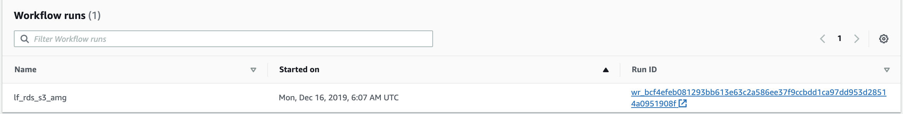
3. On the Glue Console page, click on **Get Started** and head to ETL **Workflows** in the navigation pane.
4. Here you can see the graphical representation of the Glue workflow built by Lake Formation blueprint. Highlighting and clicking on individual components will display the details of those components (name, description, job run id, start time, execution time)
5. To understand what all Glue Jobs got created as a part of this workflow, in the navigation pane, click on **Jobs**.
6. Every job comes with history, details, script and metrics tab. Review each of these tabs for any of the python shell or pyspark jobs.

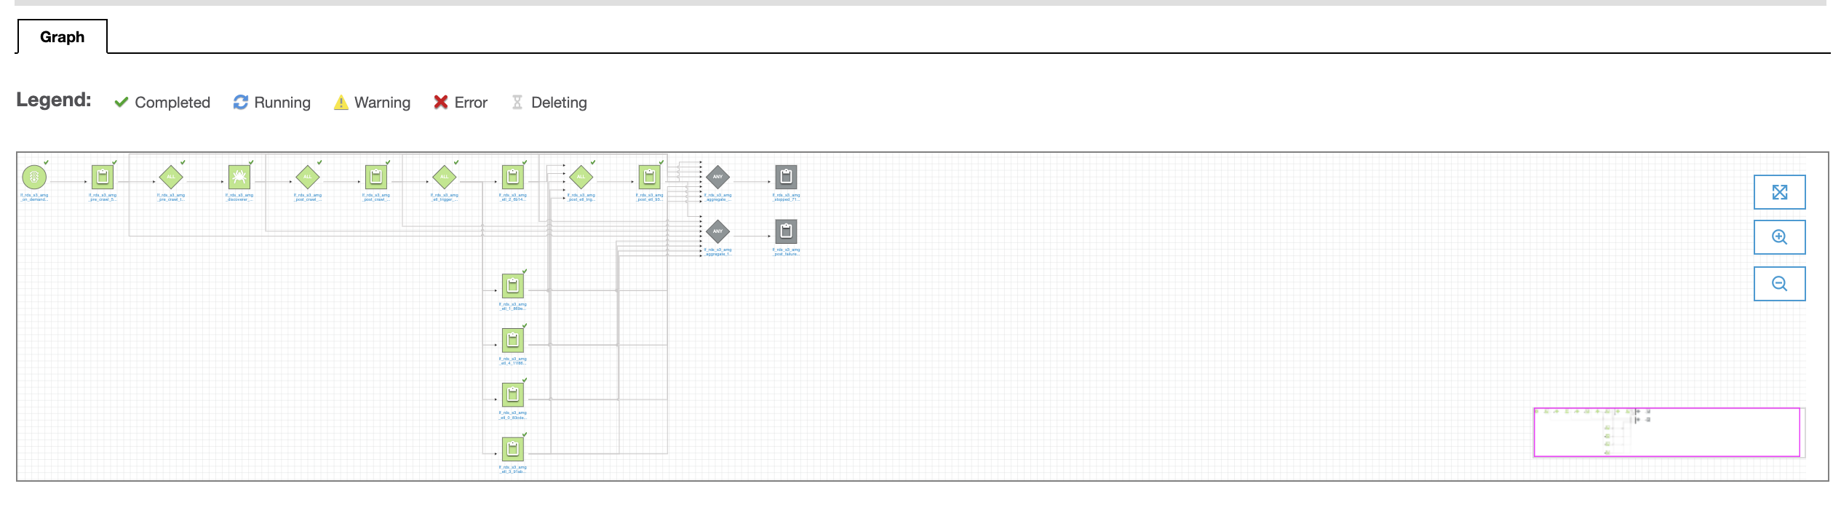

# Explore workflow results in Athena

1. Navigate to the Glue console



1. Navigate to **Databases** on the left panel and select **ticketdata**
2. Click on “Tables in ticketdata” and this table will be pre fixed by “**lakeformation_**”

Example: lakeformation__sportstickets_dms_sample_player

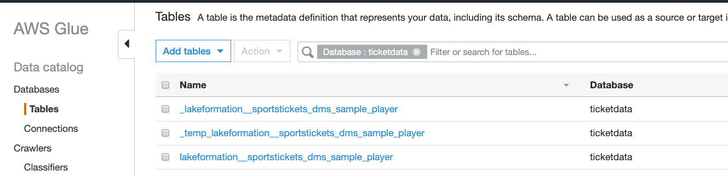

1. And Click **Action** -> **View Data**

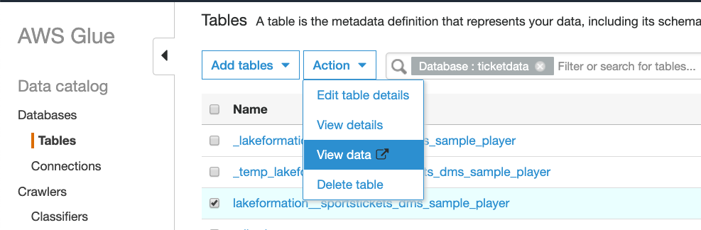

1. This will now take you to **Athena** console, where you can preview the table contents, as show below;

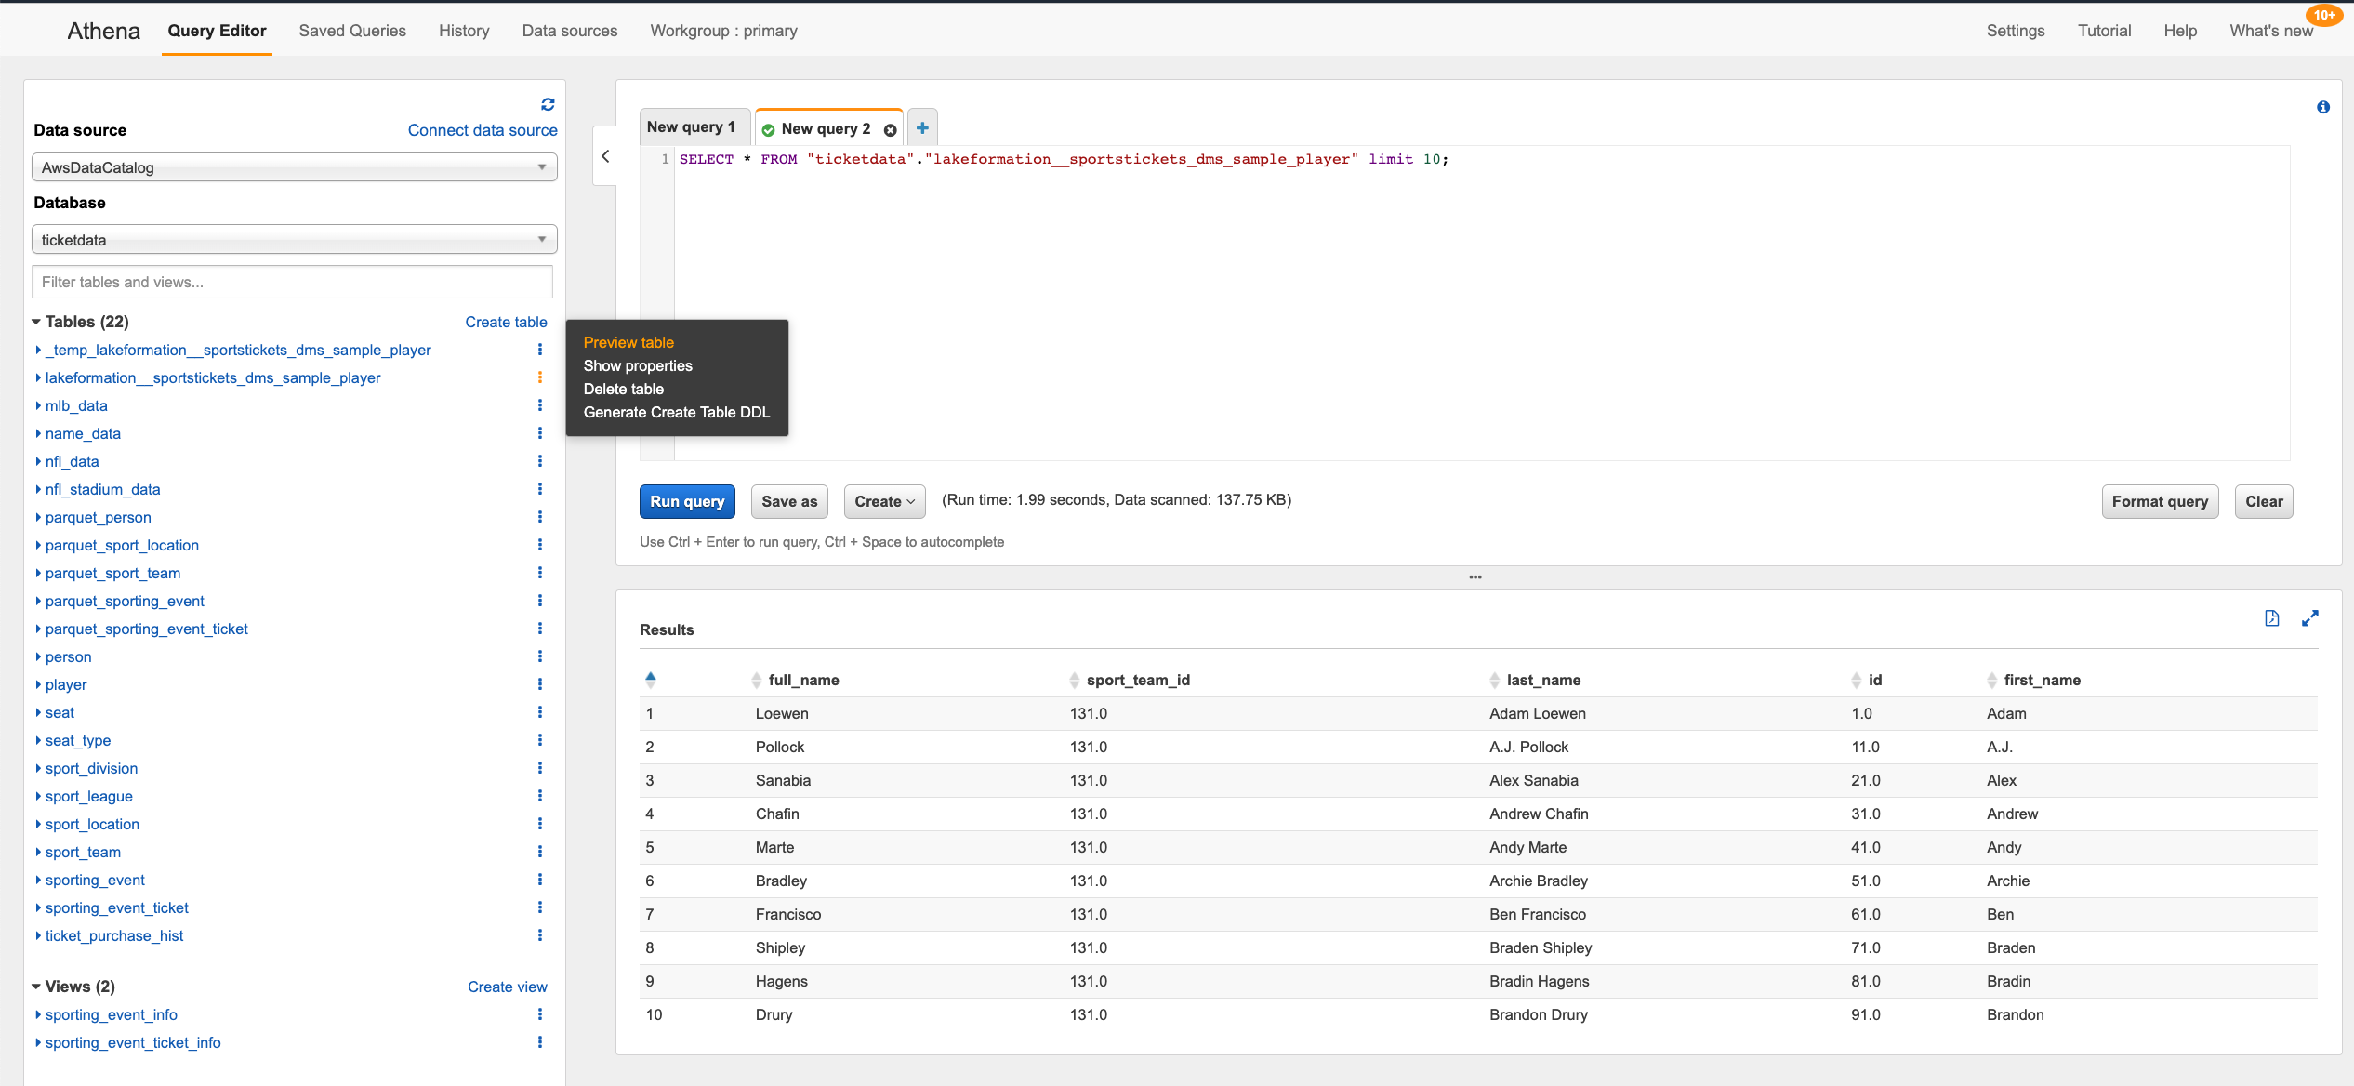

**Congratulation!!! You have completed lake formation lab. To explore more fine grain data lake security feature, continue to next section.**

# [Optional] Grant fine grain access controls to Data Lake user

Before we start the querying the data, let us create an IAM User **datalake_user** and grant column level access on thetable created by the Lake formation workflow above, to **datalake_user.**

1. Login as admin user to your account. Navigate to **IAM Console** and click on **Add** **User**.

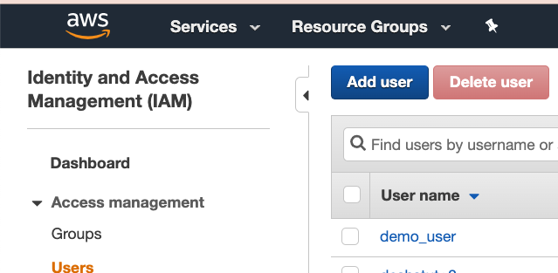

1. Create a user named **datalake_user** and give it a password: master123.

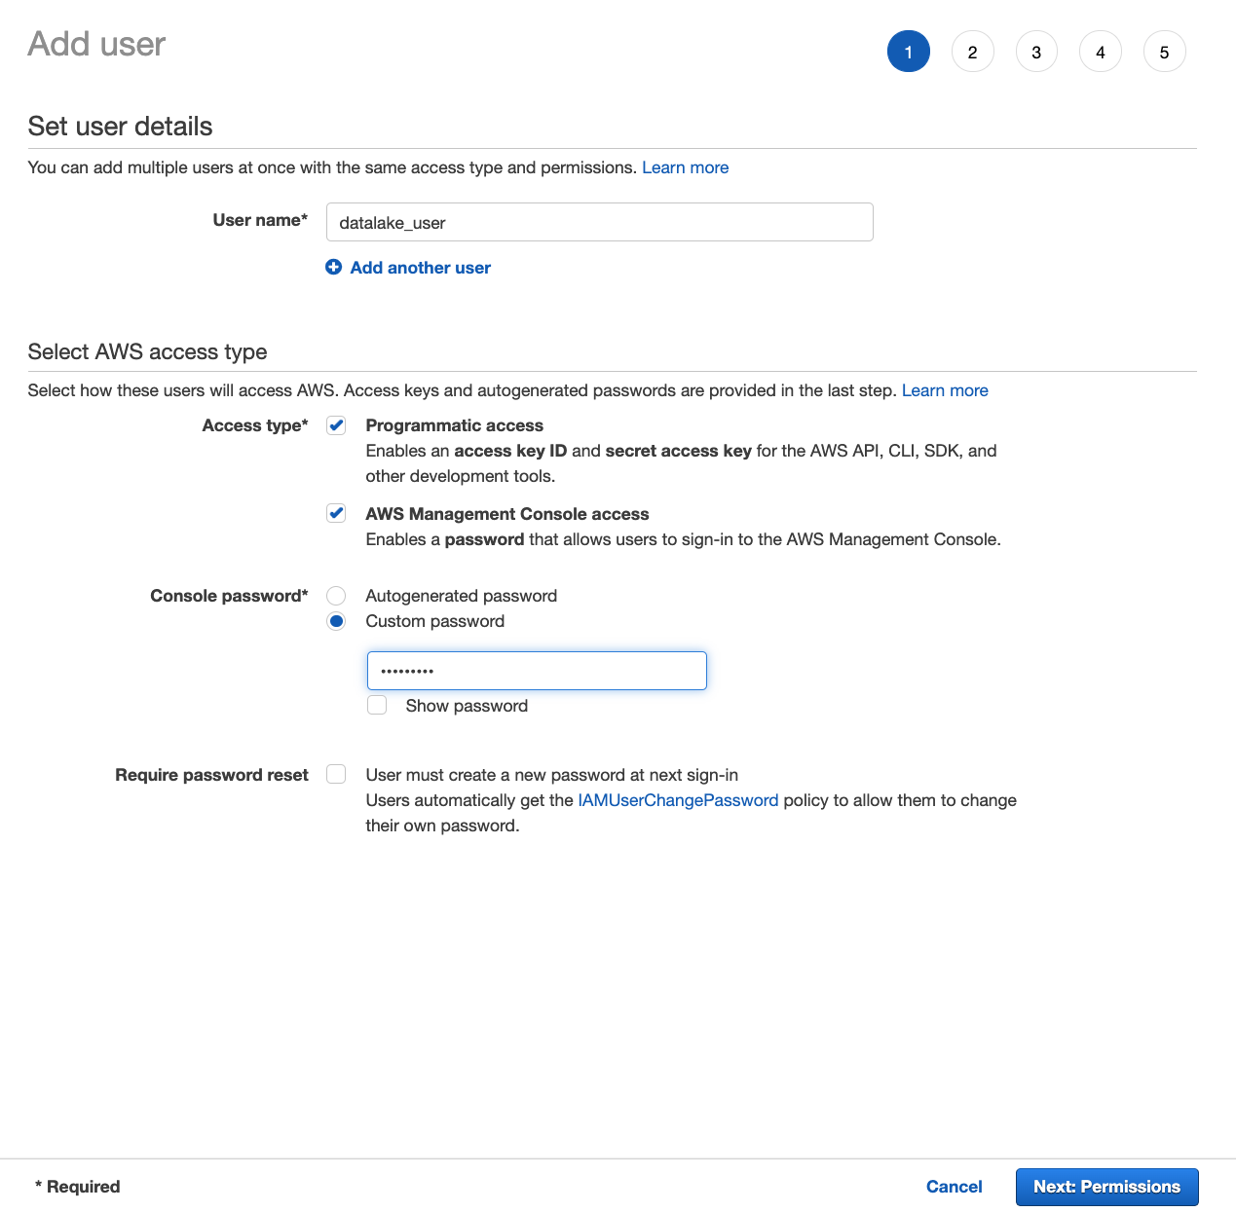

1. Next click on **Permissions** and keep navigating to the next steps until reached the end. Review the details and click on “**Create User**”.

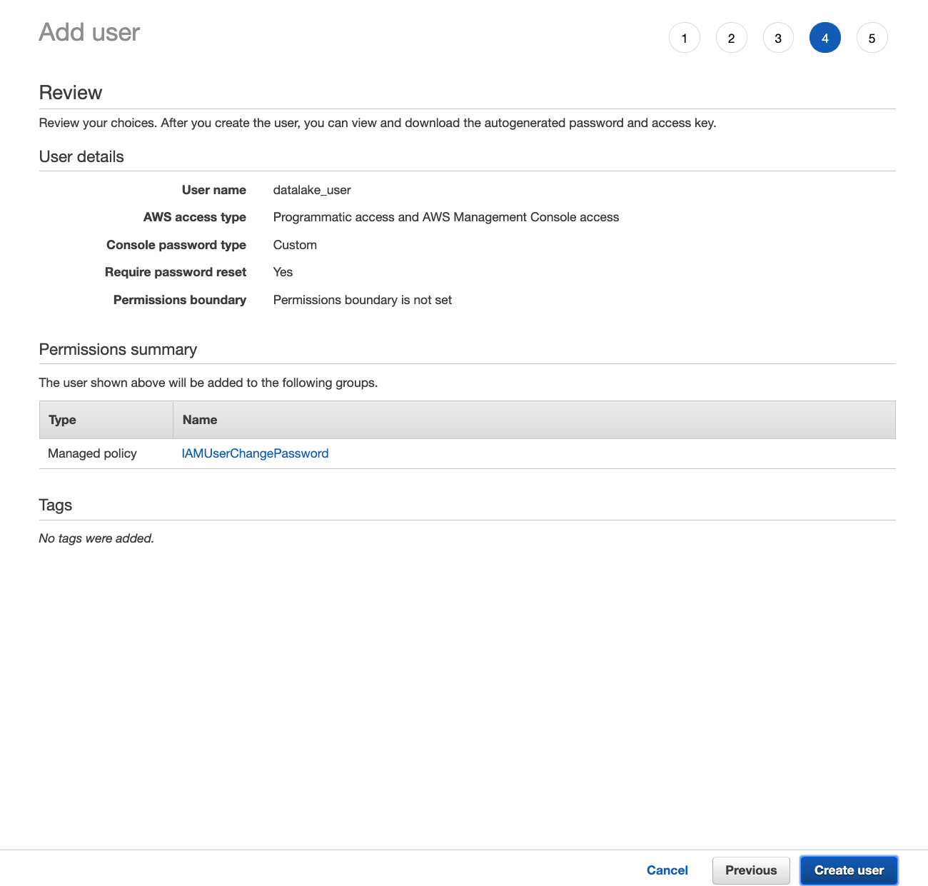

1. Navigate to the **Lake Formation console**, in the navigation pane, under **Permissions**, choose **Data permissions**.

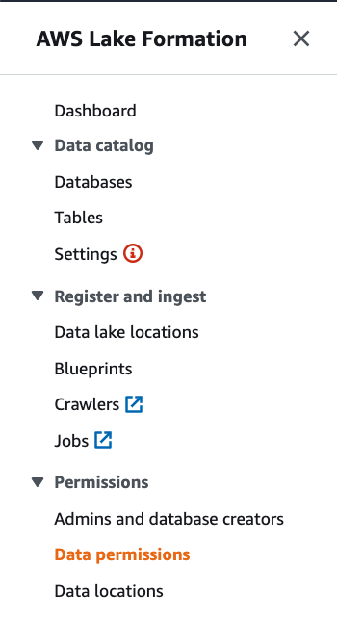

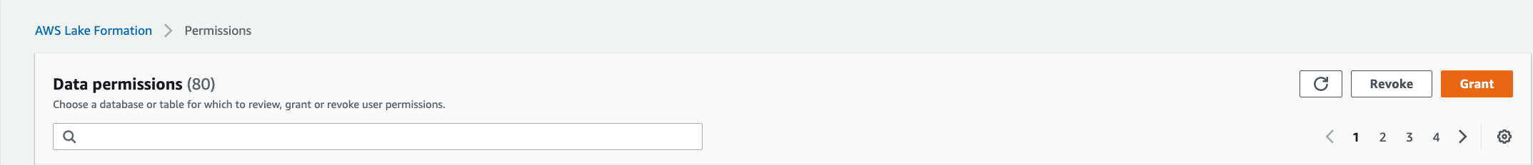

1. Choose **Grant**, and in the **Grant permissions** dialog box, do the following:
   1. For **IAM user and roles**, choose **datalake_user.**
   2. For **Database**, choose **ticketdata**
   3. The **Table** list populates.
   4. For **Table**, choose the table shown.
   5. For Columns, select **Include Columns** and choose **id**, **first_name**
   6. For **Table permissions**, choose **Select**.
2. Choose **Grant**.

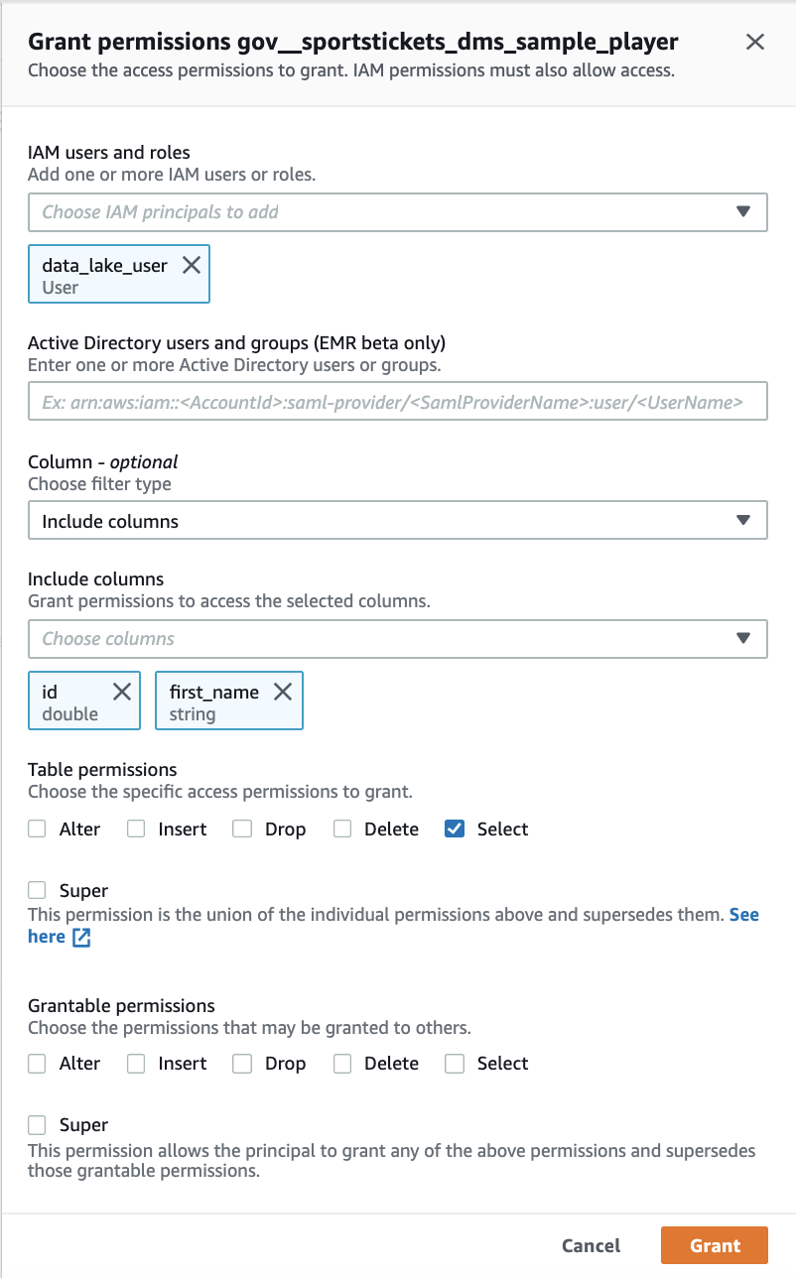

# [Optional] Verify data permissions using Athena

Using Athena, let us now explore the data set as the **datalake_user**.

1. Sign in to AWS account with account ID and username as the **datalake_user** user – **datalake_user** (username: **datalake_user)**
2. Navigate to **Amazon Athena** console.
3. Before you run your first Athena query, you need to **set up a query result location** in Amazon S3. On the right side of the Athena console, click on **Settings** and type in the S3 bucket location. The entry should look something like this: s3:// athenaqueryresults-<Accountnumber>/
4. Next, ensure database **ticketdata** databaseis selected.
5. Now run a **Select** query on the table within the **ticketdata** database. There should be only one table in there, which was created by Lake Formation workflow.
6. You will see that the **datalake_user** can **only see the columns id, first_name** in the select query result. The datalake_user cannot see last_name, sports_team_id, full_name columns in the table**.** This is because, datalake_admin gave **datalake_user** permissions to only select fromtable for the **id** and **first_name** columns.

